**📝 Project Report: Dog vs Cat Image Classifier using Transfer Learning and Flask**

**📌 Project Title**

**Dog vs Cat Image Classifier** using MobileNetV2 and Flask

**🎯 Project Objective / Purpose**

The aim of this project is to build a deep learning-based image classifier that can accurately distinguish between images of **dogs** and **cats**.  
It includes a simple and attractive **web interface** where users can upload an image, and the model returns a prediction with confidence.

**🧠 Technologies & Tools Used**

| **Component** | **Technology** |
| --- | --- |
| Programming Lang | Python 3.12 |
| Framework | Flask (for web app) |
| Deep Learning | TensorFlow + Keras |
| Transfer Learning | MobileNetV2 (ImageNet pretrained) |
| Frontend | HTML, CSS |
| File Handling | Werkzeug (Flask's uploader) |
| Deployment | Localhost (Flask development server) |

**🖼️ Dataset Details**

* The dataset consists of images of **cats and dogs**.
* Organized into two folders:

CopyEdit

dataset/

├── cats/

└── dogs/

* Dataset size: ~100MB
* Used 80% for training, 20% for validation
* Images resized to 150x150

**📊 Model Architecture**

* **Base Model:** MobileNetV2 (pretrained on ImageNet)
* **Custom Head:**
  + GlobalAveragePooling2D
  + Dense(128, ReLU)
  + Dense(1, Sigmoid)
* **Training Strategy:**
  + Phase 1: Freeze base model, train top layers (5 epochs)
  + Phase 2: Unfreeze last 50 layers, fine-tune entire model (5 epochs)
  + Optimizer: Adam (with lower learning rate during fine-tuning)
  + Loss: Binary Crossentropy

**🌐 Web App Functionality**

* Built using Flask
* Users can:
  + Upload an image from their device
  + View the uploaded image
  + Get prediction (Cat or Dog)
  + See confidence percentage (e.g., 92.35%)

**📷 Sample Prediction Output**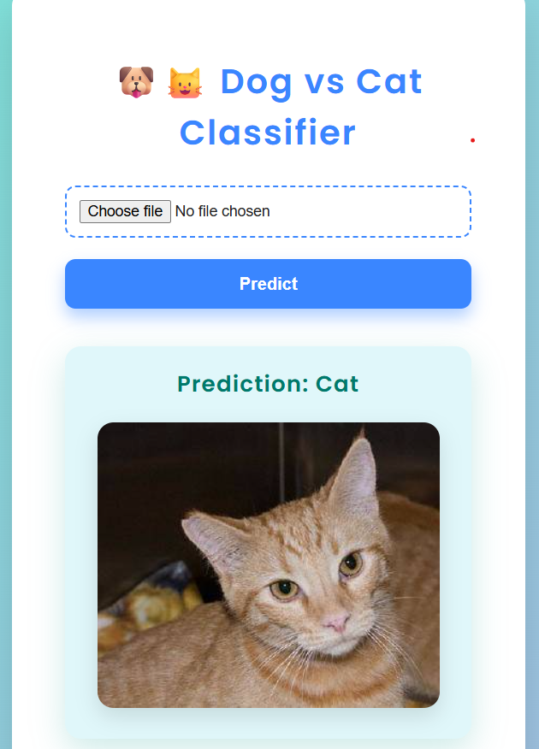

**✅ Results**

* Good performance on unseen cat/dog images
* Quick predictions through the browser
* Higher accuracy than training a CNN from scratch

**💡 Future Improvements**

* Improve UI
* Add prediction history or logs
* Include support for other animal classes

**👨‍💻 Developed By**

*Your Vishal*  
*Date: July 2025*